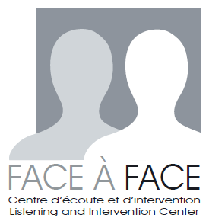
Volunteer Application Form

Contact Information

Name: __________________________ Address: _________________________________
E-mail: __________________________ _________________________________
Phone: (____)______________________ _________________________________
(____)______________________
Date of Application: ________________

Availabilities

 | Monday | Tuesday | Wednesday | Thursday | Friday
9:00 – 13:00
13:00 – 17:00

Please note your contract at Face à Face is for duration of 4 months. We understand that our volunteers have other obligations in their daily lives. We ask that you be able to commit one four hour time slot each week for duration of 4months.

The volunteer training period takes place three times a year, prior to each session, on the 1st or 2nd weeks of January, May, and September. If you do not hear a response from us please do not hesitate to contact us for additional information. Notifications will be sent out closer to the training period.

Applicant Characteristics

Languages spoken: _______________________ ______________________________
(Bilingualism required) _______________________ ______________________________

Please list any previous volunteer experience

Volunteer Interests

What types of volunteer opportunities are best suited to your abilities? (Select all that apply)

□ Direct services to those in need (front-line worker) □ Organizing events
□ Translating information □ Fundraising

How did you hear about Face à Face?

□ Volunteer Bureau of Montreal □ Website □ School
□ Current or former volunteer at Face à Face □ Other: __________________

Why are you interested in volunteering at Face à Face?

________________________________________________________________________________________________________________________________________________________________________________________________________________________________________________________________________________________________________________________

